**TReX** (Topic-based Resource eXplorer)  **Architecture**

1. **UML Diagrams**

**1.1. Class Diagram**

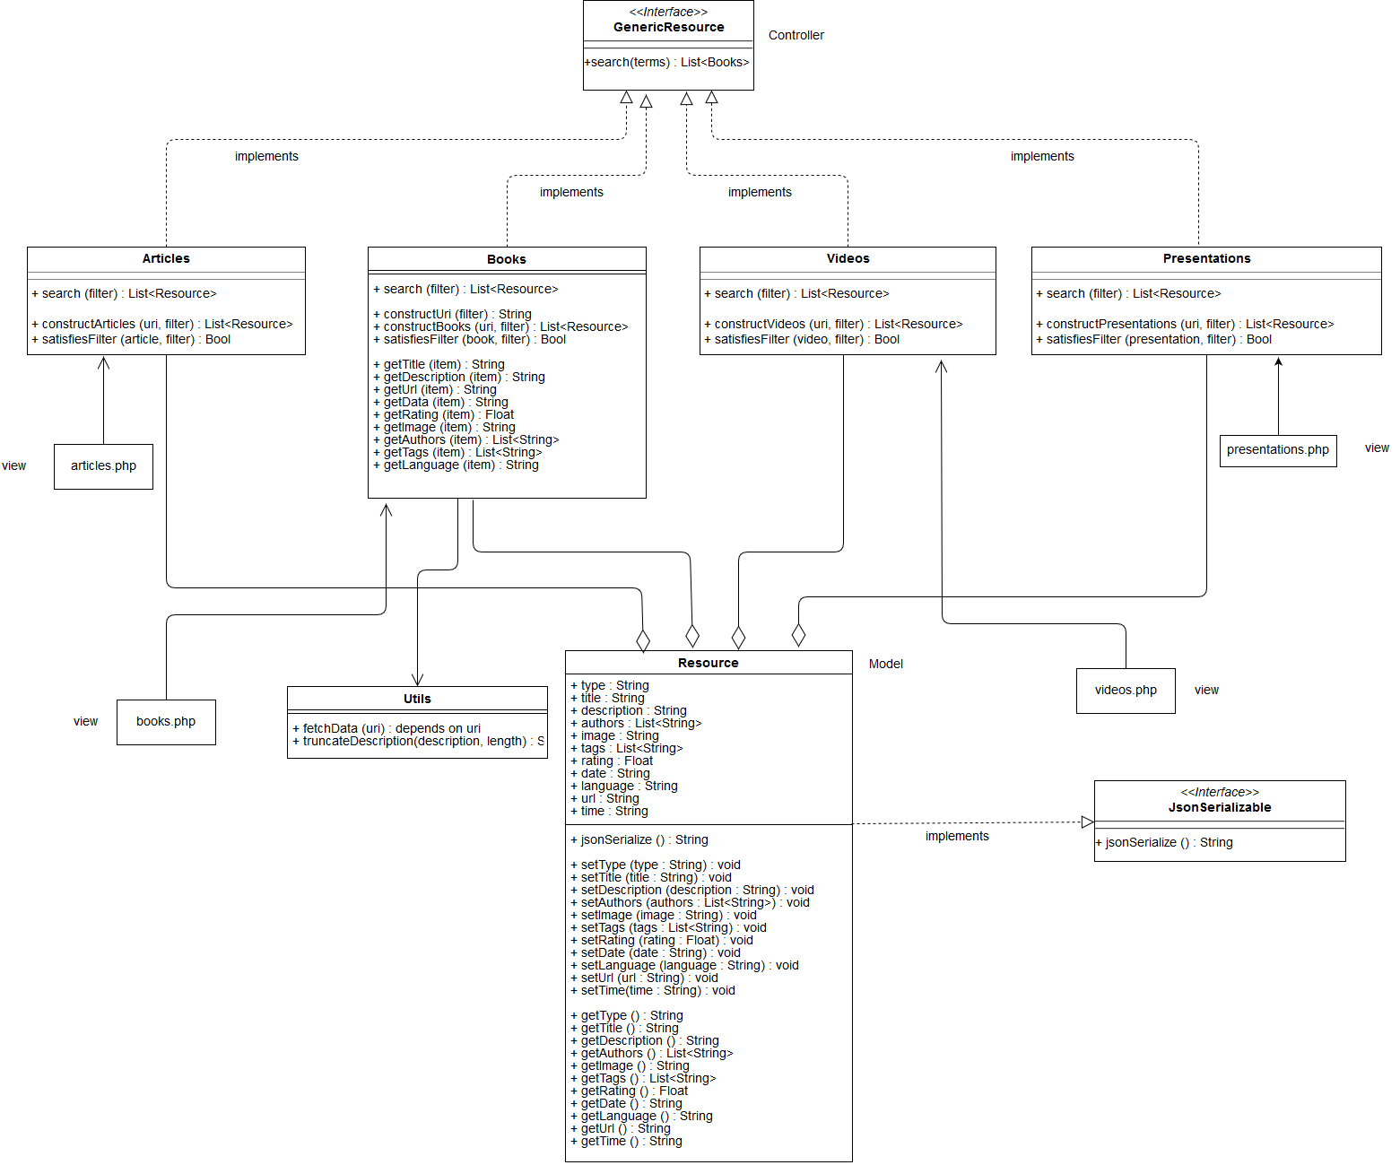

**1.2. Components**

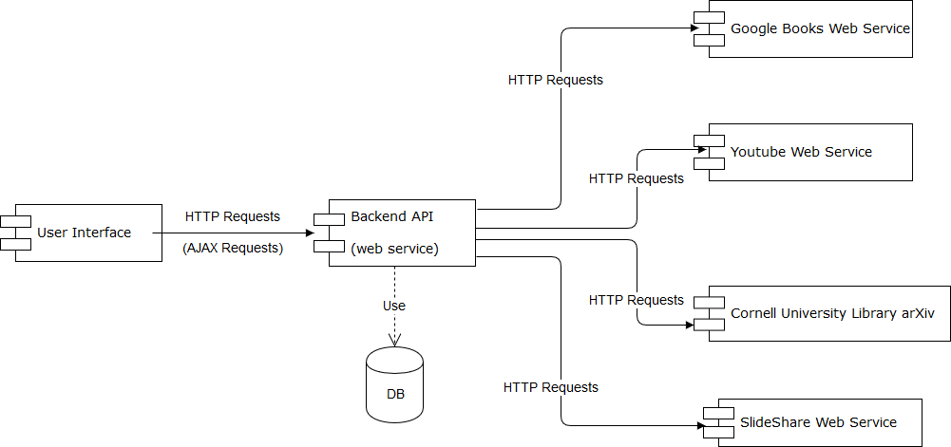

**1.3. Deployment**

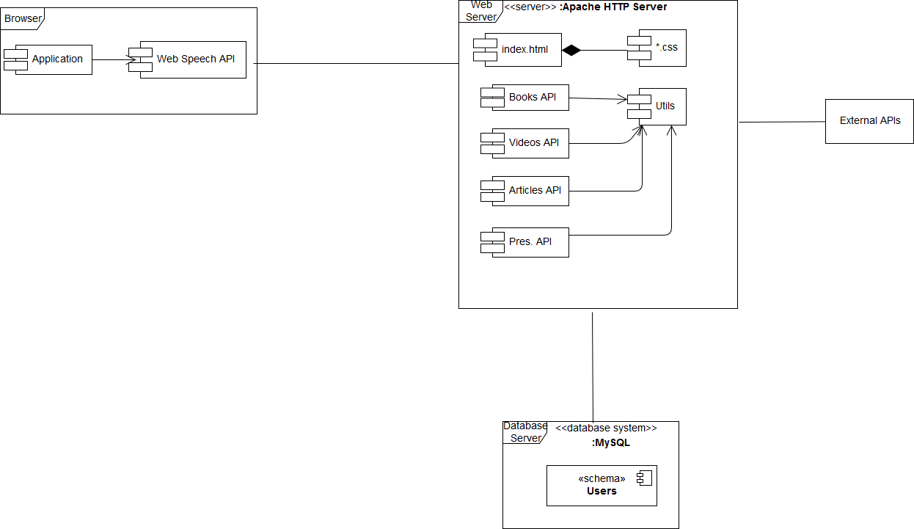

**1.4. Sequence**

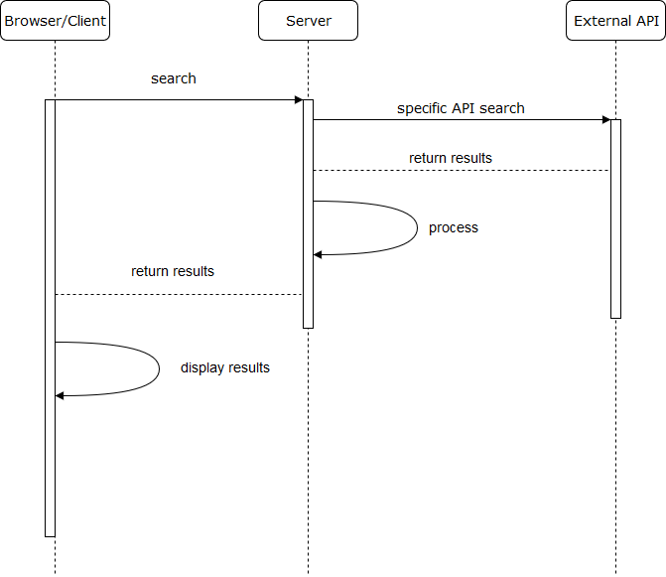

**1.5. Database Schema**

We have opted for a relational database because:

* our schema is simple
* the number of requests will be relatively small and a SQL database will scale
* we are already familiar with this technology

The first time when a user connects to our application, a hash function will be applied to the password entered by user and the result of the hash function will be stored in the database in the password field. Each time thereafter, when a user wants to connect, the result of the hash function applied to the password it is compared with the information stored in the password field next to the user with that username.

The email field will store the user's email address, being useful for password reset.

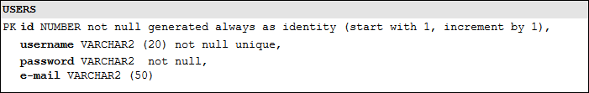

**2. Use Cases**

Our application addresses both regular and programmatic clients.

